
Barbie’s Greenhouse
Elements list
For the scale model:
Cardboard
Baking paper
Scotch tape
For the final greenhouse:
Wood (for the load-bearing structure and lid)
Green paint (for wood)
Plexiglass (for transparent walls and lid surface)
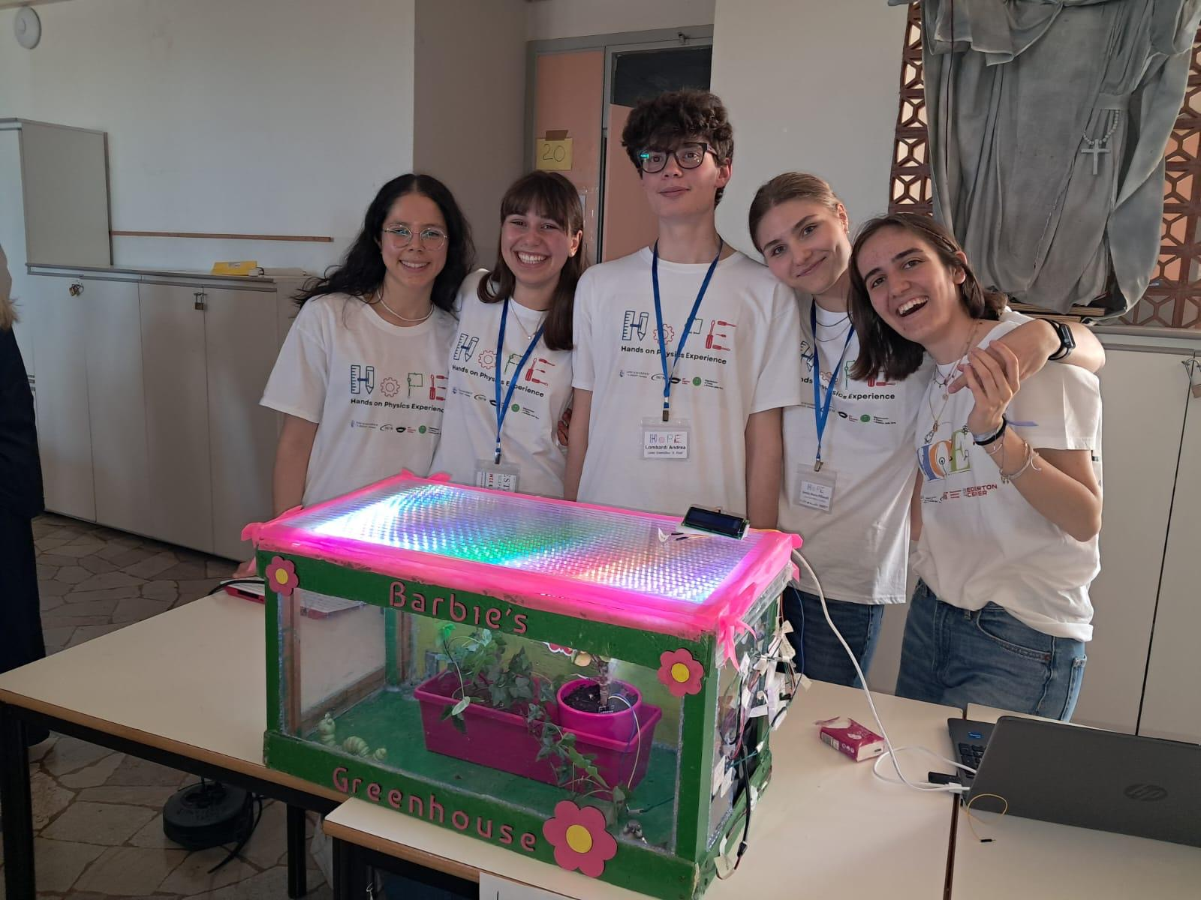
Silicone (for gluing wood and plexiglass)
Plywood (for decorative flowers)
Fuchsia paint (for decorations)
Fuchsia bows and ribbons (for decoration)
Ceramic objects (caterpillar and little bird decorations)
Plants:
Fuchsia carnations
Climbing ivy
For the electronic components:
Buzzer
Pump
Fan
LCD Display
Ground Humidity Sensor
Photoresistor
Air’s Humidity and Temperature Sensor
LED Strip

Design and Construction of “Barbie’s Greenhouse”
To build our greenhouse, we started with a scale model made with cardboard and baking
paper, simple but effective materials to simulate the shape and transparent effect typical of
glass. The structure of the model, like that of the final greenhouse, is a parallelepiped, a
regular and functional geometric shape. The various parts of the model were assembled
using scotch tape, which allowed us to build it quickly and precisely.
Once the project was defined, we built the actual greenhouse in the laboratory, using wood
for the load-bearing structure and plexiglass for the transparent walls. Before assembly, the
wood was painted green, a color chosen to recall the vegetation and make the aesthetics of
the greenhouse more harmonious. To join the various elements, we used silicone, ideal for
gluing both wood and plexiglass, ensuring stability and cleanliness in the joints.
After cutting the plexiglass to size and assembling the entire structure, we added a wooden
interlocking lid with a transparent central surface to allow the interior to be seen from above.
The greenhouse was decorated with fuchsia bows and ribbons, the symbolic color of our
logo. On the front we applied the writing “Barbie’s Greenhouse”
, accompanied by three small
plywood flowers, precisely cut using a laser cutter and then painted fuchsia as well. Inside,
to make the environment more welcoming and personalized, we inserted our laser-engraved
logo and glued it to the wall.
To complete the setup, small decorative ceramic objects were added, including a caterpillar
(which recalls the character in the logo) and a little bird. As for plants, we chose fuchsia
carnations and climbing ivy, which make the greenhouse alive and consistent with the
chosen theme.

Greenhouse Automation and Programming
For the construction of the greenhouse, from an electronics and informatics perspective, we
began by testing each sensor individually. We started with the simplest ones, such as the air
temperature and humidity sensor and the soil moisture sensor.
Once the individual components were tested, we integrated them into a complete program
that governs the greenhouse’s operation. The program is based on conditional logic, where
each condition triggers a specific response from the system. For example, when the
temperature rises above a certain threshold, the fan activates to stabilize the environment;
similarly, if the soil moisture sensor detects low humidity, the pump turns on to water the
plants. Inside the greenhouse, several automated systems can be identified:
Irrigation system: Composed of the soil moisture sensor and the water pump, this system
operates through conditional programming to water the plants as needed. It also includes a
water level sensor in the tank, connected to a buzzer that alerts when the water level is too
low. Ventilation system: Made up of the air temperature and humidity sensor and the fan, it
ensures a ventilated environment with stable temperatures that support plant growth.
Lighting system: Consisting of an LED strip and a photoresistor, it detects ambient light
levels and activates the LEDs accordingly. Additionally, the LEDs can be manually turned on
via an external button, regardless of light conditions.
To provide real-time monitoring, we added an LCD screen that displays the data collected
from inside the greenhouse, allowing external observation of environmental parameters. All
these systems work together to maintain optimal conditions for plant well-being without
human intervention, making the greenhouse largely self-sufficient.
