Alfonso Siluro II

The project is a 1:50 scale model of the Estense Castle in Ferrara. It features four pools, one of which includes a fountain, a drawbridge, and lights all around, operated by a single Arduino. The water flow of the pump that activates the fountain is regulated by a distance sensor. The castle features the complete restoration of the structure and the reconstruction of the tanks.

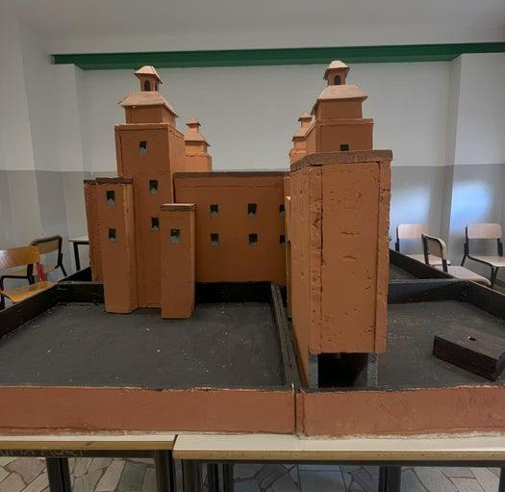
Supplies:

Tools:
- welder
- meter
- Arduino
- jumpers
- pump
- leds
- brushes
Materials:
- polystyrene
- glue
- twine thread
- colored fabric
- plywood
- tempera colors
- stucco
- waterproofing sheath
- water

Attachments
- VIDEO-2024-12-01-19-12-02 (1).mp4
- Download

Step 1: Design
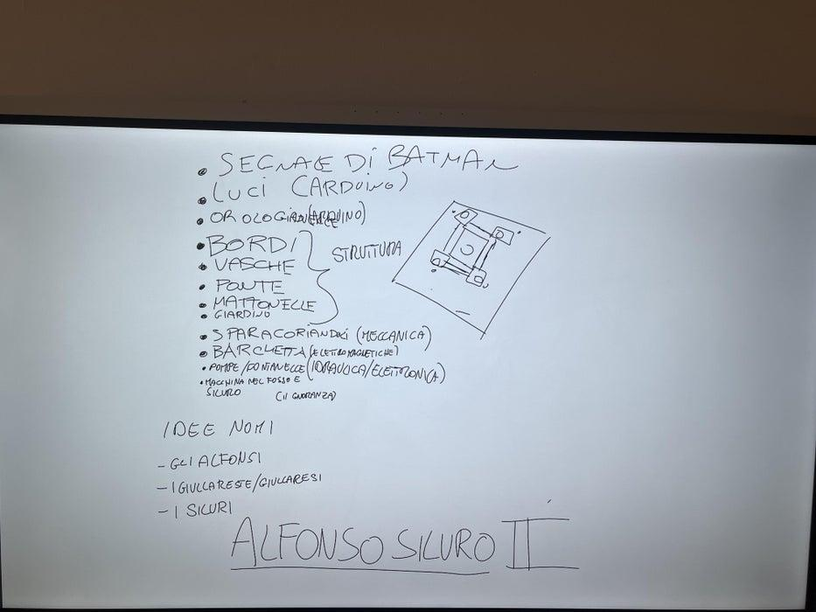
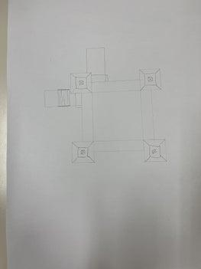
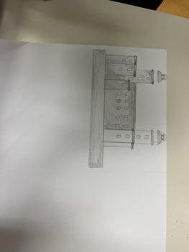
3 More Images
Firstly, we studied the already existing project: it was broken and malfunctioning, but the walls were already in scale, so we decided to not restart everything, but to recycle the structural parts of the old project. We came up with some ideas on how to renovate everything, then we did the drawings on how to assemble the different parts.

Step 2: Two Structures
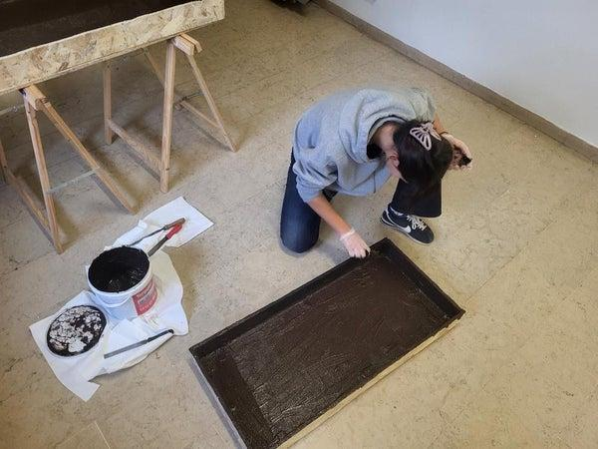
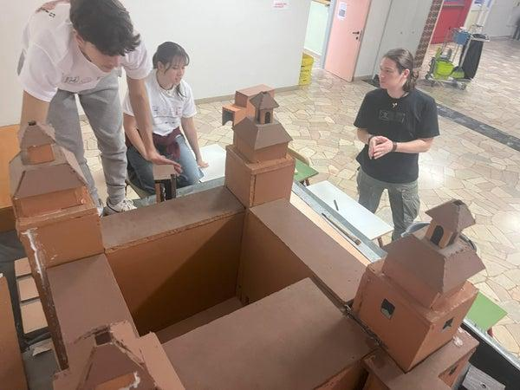
We divided ourselves in two subgroups: one that built four pools, and one that renovated the drawbridge. We built the pools in wood and coated them in waterproof sheath, while also working on creating a wood bridge (replacing the old one in polystyrene).

Step 3: Electronics
We worked on a program that controlled, with a single Arduino, the lights, the drawbridge, and the sensor and pump (through an H-Bridge). We drew some sketches on how to connect the cables and got the measurements on how long they should all be. The goal was to hide the arduino in one of the walls, and sending all of the cables outside to the different areas. Two cables would then go inside the castle to receive the current from a power supply.

Step 4: Architecture
We created skeletons in wood to reinforce the structures inside the walls, and adapted the whole thing to the new pools (thicker than the last ones). We repainted everything, making it much nicer to the eye.

Step 5: Put Everything Together
The last step, after working as two separate subgroups

