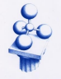
Electromagnetic Accelerator
Builders:Alessandro Sgarzi, Francesco Berra, Giovanni Manfredini, Filippo Lugli and Luca Ferranti.
Group Name:Mr. Nimbus Electromagnetic Accelerator.

Date:HoPE Project 2024/2025 Location: Branch of the A.Roiti High School, Via Azzo Novello 2

Goal of the experience:
During the development of this HoPE 2024/2025 project, I developed an ambitious and new project together with other members of the “Mr. Nimbus Electromagnetic Accelerator” group. Our goal is to create a linear electromagnetic accelerator or “coilgun” by exploiting the creation of a magnetic field inside electrified solenoids. This project unites and excites everyone as it involves branches of physics that are still unknown to us third and fourth year high school students. It was precisely the difficulty of the project that pushed us to realize it, so already in the first weeks of HoPE, after having studied the topic of electromagnetism in depth with extracurricular courses, we designed a first sketch of this project. It involved the electrification of solenoids which results in the formation of a magnetic field inside them, which can be used to attract ferromagnetic objects. Our goal throughout this project has always been to accelerate objects in non-traditional ways, and I believe this is the best project, among those proposed, to do that.

1. Theoretical Note
Unfortunately, the creation of a B field after that of an E field is a topic that is not covered in the third year of high school, consequently I had to follow courses and training online and offline to fully understand what we were trying to achieve. I will therefore share all the notions I learned in order to be able to carry out the project. Initially, it is good to understand what is meant by electric charges, that is, that property of matter that distinguishes the charges themselves based on their polarization, positive or negative. Charges of the same sign attract each other while charges of opposite signs repel each other, this happens through an electric field or E field that permeates the matter. The charges create a deformation of space in a different way, these deformations of the E field are represented by elevations or depressions in the field lines if the charge is positive or negative. Furthermore, the more intense the E field, the faster the charges will move in their attraction or repulsion motions; these relationships are expressed through the formula of the Electric Force where: . The absolute value of the charge subjected to forces is expressed as In general, the formulas for calculating the E field vary according to the arrangement of the charges in space (point, plate, wire, etc.). If, however, you want to calculate the force of attraction between two electric charges, you can use the formula for the Coulomb force, which is valid as a general rule: where k is the Coulomb constant and is the distance between the two charges.$F=q*Eq.F=k*|q1*q2|/d$
After studying this brief introduction on the E field, it is good to also know the B field or magnetic field before relating them. In fact, like the E field, the B field is also represented by field lines that indicate the direction and the sense in which it acts. In a magnet, in fact, the field lines can be represented as exiting from the north pole (positive) and re-entering the south pole (negative) following an elliptical motion. If, unlike us, you want to work with the interaction between the B field and charges, it is good to know that the latter must be in motion to be influenced by the B field itself. In fact, the force with which a magnetic field influences a moving charge is called the Lorentz force and is calculated as follows: where is the starting speed of the charge, is the magnetic field in the form of a vector and is linked by a vector product to the speed itself. In fact, the vector resulting from this product represents the Lorentz Force that conditions the motion of the charge and makes it helical (spiral). This phenomenon is also used to measure the mass of protons and electrons (mass spectrometer).$F=q*v x BvB$
The relationship between the E field and the B field was discovered by Oersted who, by placing a compass next to an electrified circuit, noticed its imprecision. In fact, by electrifying conductive materials of different shapes, magnetic fields are created formed by field lines with different directions and consequently the formulas for calculating the intensity of the B field also vary. The formula we used to calculate the intensity of the B field at the midpoint of the solenoid, where it is maximum, is: where k is the permeability constant of the medium in which the B field develops, N is the number of turns of the coil, is the current and is the length of the solenoid.$B=(k*N*i) /lil$
At the end of my research we knew that the point where the magnetic attraction was greatest was the midpoint of the solenoid and that the field lines of the B field followed an elliptical motion just like in any magnet, with a direction converging at the midpoint.
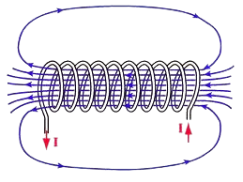

2. List of Materials and Tools Used
- Insulated copper wire, (enamelled) thickness approx. 0.5 mm length approx. 250 m
- Coil supports, plastic tube section diameter approx. 10 mm length approx. 4 cm
- Coils made, 400 wdg approx. length 3.5 cm.
- Transparent plexiglass tube, thickness approx. 1 mm, length approx. 1.3 m, internal diameter approx. 8 mm
- Wooden supports for the tube, square and perforated with a side of approx. 7 cm
- Straw to stop the ball, diameter approx. 1.5 mm
- Ferromagnetic ball diameter approx. 6 mm.
- Single 3-output relays;
- Arduino Uno;
- Photosensors and photoresistors;
- Resistors and LEDs of different types and sizes;
- Voltage generator 30V 400A;
- Computer with Arduino IDE;
- Multimeter for voltage, current and resistance;
- Virtual Oscillometer;
- Software for the creation of 3D and/or CAD projects;
- Homemade knob for solenoids;
- 9V batteries;
All the materials were provided to us by the teachers of the Roiti high school, by the experts of the MIT or by the collaborators of the INFN.

3. Project Description
The interest in accelerating bodies in non-traditional ways is fully embodied by our final project. The motion of the ferromagnetic body is in fact made possible by the magnetic attraction exerted by the coils. After having partially studied electromagnetism it was clear to us that the solenoid acted as an accumulator of electrical energy that leads to the formation of a B field which, as already mentioned, in our project, helps the acceleration of the ball only halfway by attracting it towards the center. It is easy to understand how when the midpoint of the coil is passed the moving body is slowed down and sometimes stopped and then changes the direction of motion towards the midpoint of the accumulator. To avoid this problem it is necessary to activate the coils in sequence, knowing that there are different ways to do it we have chosen the one that includes the use of photosensors. However, this system does not work when the ball is still, because it is impossible to detect the movement, so for the first solenoid we used a relay that, behaving like an automatic switch, electrifies the solenoid for a few moments; just enough to give an initial impulse to the body. For the following coils, however, the current flow begins only when the previous one has turned off, so as to make the most of the first half of the magnetic field, avoiding prolonging the current flow that would overheat them. The end of the electrification of the solenoid is always dictated by the same relay, which manages the ignition phase, and opens the circuit a few moments after the detection of the body at the coil input. In other words, the coils turn on when the previous one turns off and turn off with a delay compared to the detection by the photosensor. Obviously, the photosensors regulating all the timing are placed before the start of the solenoid and all the delays and moments used derive from experimental tests. The Arduino that manages the relays is unique and is programmed through the Arduino IDE software with which we programmed the code reported shortly. The power supply of the relay switches themselves (COM port) occurs through a voltage generator set to 5 or 9 Volts. As for the supporting structure, it is made of a transparent plexiglass tube through which the LED and the photoresistor can communicate. To improve this communication, the tube could be drilled to insert the optical components, but this would increase friction. The tube is also supported by plywood parallelepipeds that hold the main tube a couple of centimeters from the ground. A straw is inserted into the initial end of the "barrel" which has the task of keeping the body in the same starting position (by varying the initial position, the previously programmed timings would prove ineffective) without increasing the friction of the air in the tube (without blocking the end).

Video of the Electromagnetic Accelerator working : https://youtube.com/shorts/KwLBeeGBZYk

4. Project Schematic/Drawing/Code/CAD
In every project it is good to visualize an image of the final product before starting the manufacturing phase; to do this in the industrial world CAD of the projects are built, that is 3D representations of them. We designed the CAD of the external structure of the accelerator just before the intensive week to be able to visualize the measurements and intervals at which to place the coils from each other. To do this we used OnShape, here are some angles of the project:
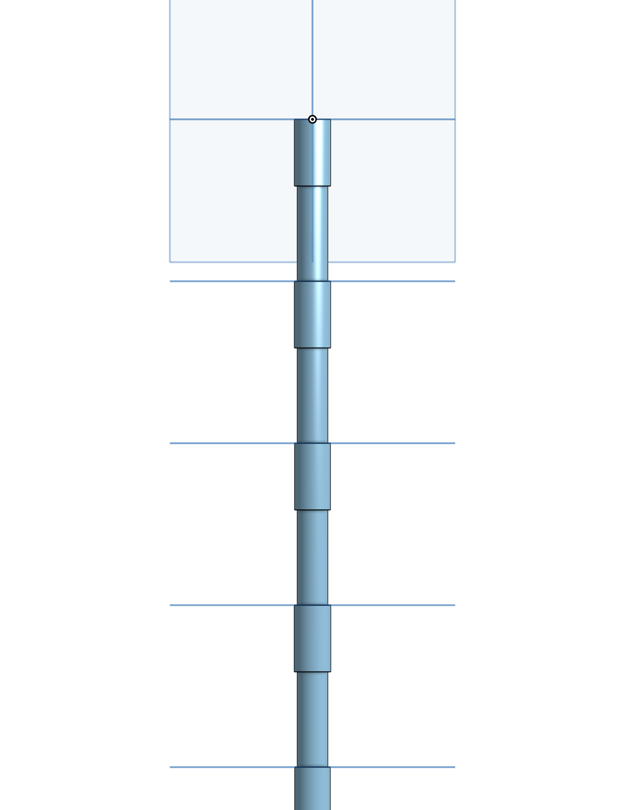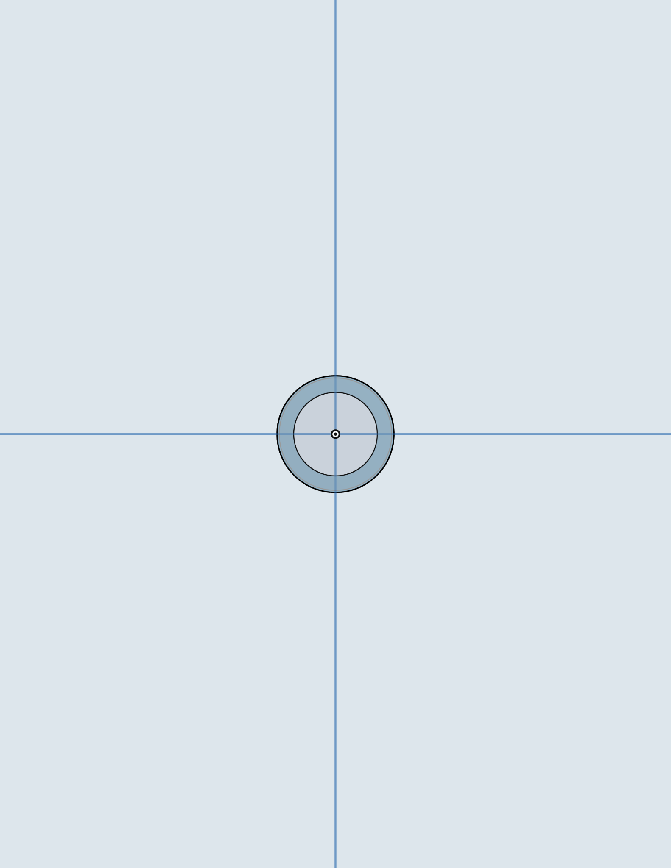
After that, applying what was said above, you can develop a simulation of the electrical circuit, schematized below, using TinkerCad to verify the validity of your reasoning without risking breaking components and in a fast and intuitive way. Below I report the electrical diagram of the first coil, started with the correct timing (1), of the following coils, started using photoresistors (2) and a simplification of the entire electrical system (3).

1:
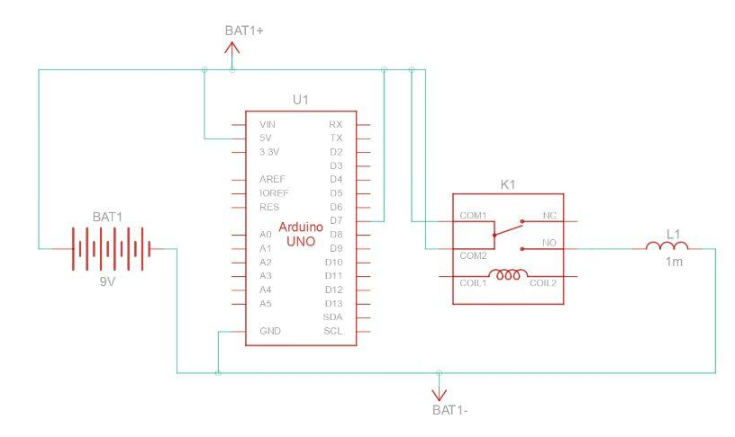
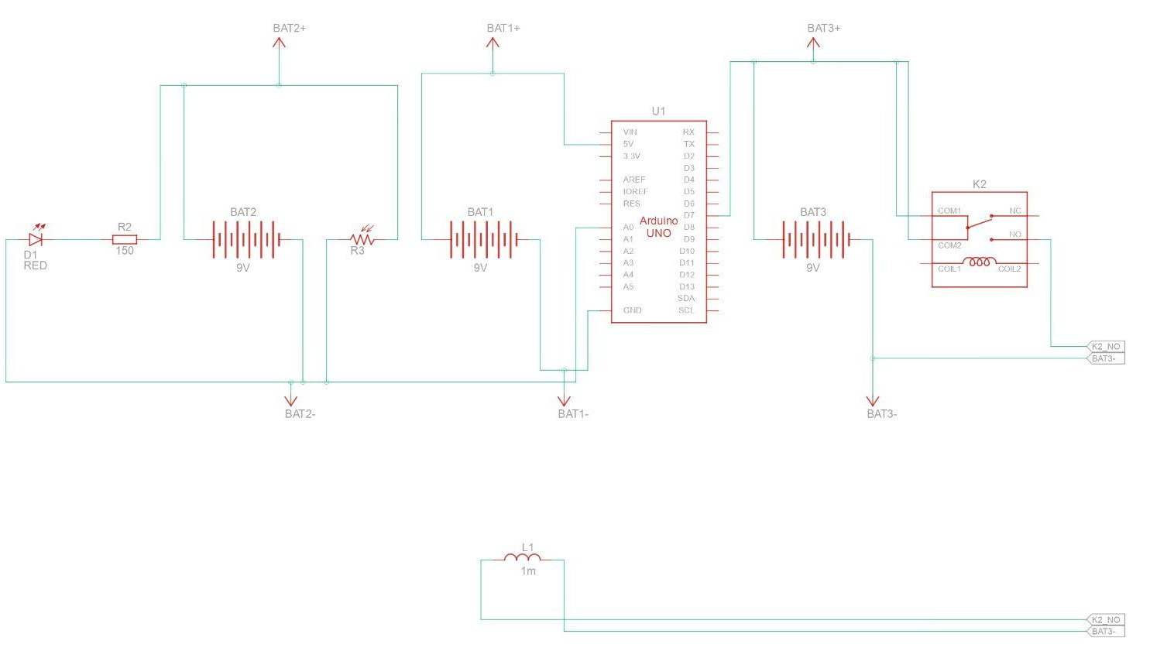
2:

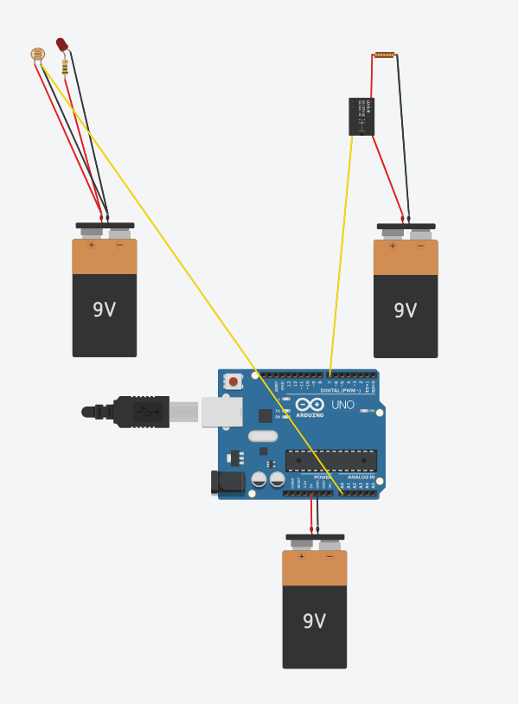
3:

As we will see later, we also used TinkerCad to run several simulations of how the system should work in order to then proceed with the assembly of the components. To do this, however, in addition to the electrical representation, an Arduino IDE code is also needed that defines the operation of the Arduino itself. The purpose of our code is to turn off the coil a few moments after the ball is detected by the photosensor. Below is a portion of code coordinating the first two coils.

const intphotoPin2 = A4; // Pin of the first photoresistor

const intrelay1 =4; // First relay pin

const intrelay2 =5; // Second relay pin

intreferenceLight2; // Average reference brightness value for the first photoresistor

intsum2 =0; // Sum to calculate the average brightness of the first photoresistor

void setup() {

unsigned longstartTime =millis();

// Setting the pins

pinMode(photoPin2, INPUT);

pinMode(relay1, OUTPUT);

pinMode(relay2, OUTPUT);

// Initialize the relays

digitalWrite(relay1, LOW);

digitalWrite(relay2, LOW);

// Calculate reference brightness for the first 3 seconds

while (millis()- startTime <=3000) {

intlightValue2 =analogRead(photoPin2);

sum2 += lightValue2;

delay(100); // Delay to avoid too frequent readings

}

// Let's calculate the average reference brightness

referenceLight2 = sum2 /30;

// We activate the first coil for a short time

digitalWrite(relay1, HIGH);

delay(110); // 0.11 seconds

digitalWrite(relay1, LOW);

// Start serial communication for debugging

Serial.begin(9600);

}

void loop() {

// Reading the brightness from the first photoresistor

intlightValue2 =analogRead(photoPin2);

Serial.println(lightValue2); // Print brightness value for debugging

// Calculate the brightness threshold (90% of the reference value)

intmaxLight2 =0.9* referenceLight2;

// I check if the first relay is off and turn on the second relay

if (digitalRead(relay1)== LOW) {

if (lightValue2 < maxLight2) {

// If the brightness is below the threshold, I turn on the second relay for a short time

digitalWrite(relay2, HIGH);

delay(100); // Second relay activation time

digitalWrite(relay2, LOW);

} else {

// If the brightness is above the threshold, I keep the second relay on

digitalWrite(relay2, HIGH);

}

} else {

// If the first relay is on, I turn off the second relay

digitalWrite(relay2, LOW);

}

delay(100); // Delay to stabilize the loop

}

The code sequences the first and second coils, for the following ones it will be identical, the initial part of it electrifies the first relay for 0.11 seconds (experimental time) giving an initial impulse to the body. It also develops an estimate of the external light so that it can be used as a reference later. The second coil instead turns on only when the previous one has turned off so as not to overheat or interfere with the previous magnetic field. It will turn off instead a few moments after the light detected by the photosensor is less than that of the environment, due to darkening of the LED due to the passage of the body. The estimate of the light of the environment (and that of the LED) is determined by measuring 30 values ​​of it (1 every hundredth of a second for 3 seconds). Subsequently, as a reference and threshold to be able to determine the darkening of the photoresistor, and therefore the passage of the body, only 90% of the estimated light will be taken into account so as to limit random errors.

5. Project Exhibitions

Un aspetto fondamentale del progetto HoPE è l’organizzazione di esposizioni periodiche dei lavori svolti, aperte a tutti i cittadini. Questi momenti rappresentano un'importante occasione per condividere i risultati raggiunti e per sentirsi parte di un progetto comune. Oltre alle esposizioni teoriche, utili per mantenere aggiornati studenti e docenti sugli obiettivi perseguiti, abbiamo avuto anche l'opportunità di presentare concretamente il nostro lavoro presso il Centro Scientifico Universitario di Ferrara. In particolare, nel pomeriggio di domenica 2 febbraio 2025, a conclusione dell’Hackathon organizzato da HoPE, siamo stati invitati a mostrare ai partecipanti quanto prodotto fino a quel momento durante gli incontri del progetto. Nel nostro caso, siamo riusciti a presentare una bobina funzionante, capace di accelerare un corpo attraverso un breve impulso. Il pubblico è rimasto colpito nel vedere con i propri occhi la forza effettiva del campo magnetico, le sue implicazioni pratiche e la sua formazione a partire da un campo elettrico.

6. Experimental Project Data Table

The voltage used was 10 V, with a current of approximately 1.4 A. For safety reasons, we were restricted to working with low voltage and prohibited from using voltage transformers. This limitation ensured a safer working environment, although it also constrained certain aspects of the experiment. In future iterations, incorporating voltage transformers, under appropriate safety protocols, could enhance the flexibility and scope of the setup.

7. Measurements of Constant Values ​​(Inductance, Resistance, Frequency)
On the advice of Professor Ed Moriarty, to maximize the performance of the accelerator, we decided to study the interactions between the coil, the E field and the B field. Consequently, we calculated the resistance and inductance of the solenoid. To calculate the first, we initially relied on “prepackaged” formulas and then verified the calculations experimentally by putting the multimeter and the solenoid itself in parallel. By putting the multimeter in parallel, in fact, it is possible to calculate the resistance exerted by the solenoid on the current flow by comparing it to that of the multimeter, which is zero.
$$R=p*(L/A)=1,716 Ω$$
$R$=resistance;
$p$=electrical permeability of the material used (copper=1.68 * 10-8m);$Ω$
$L$=length of solenoid wire (in our case 20.1m);
$A$=sectional area of ​​the wire (in our case 1.964* 10-7 m2);
We then proceeded by placing the ends of the multimeter adjacent to those of the solenoid so as to put it in parallel and measure its resistance experimentally. The result is the following:
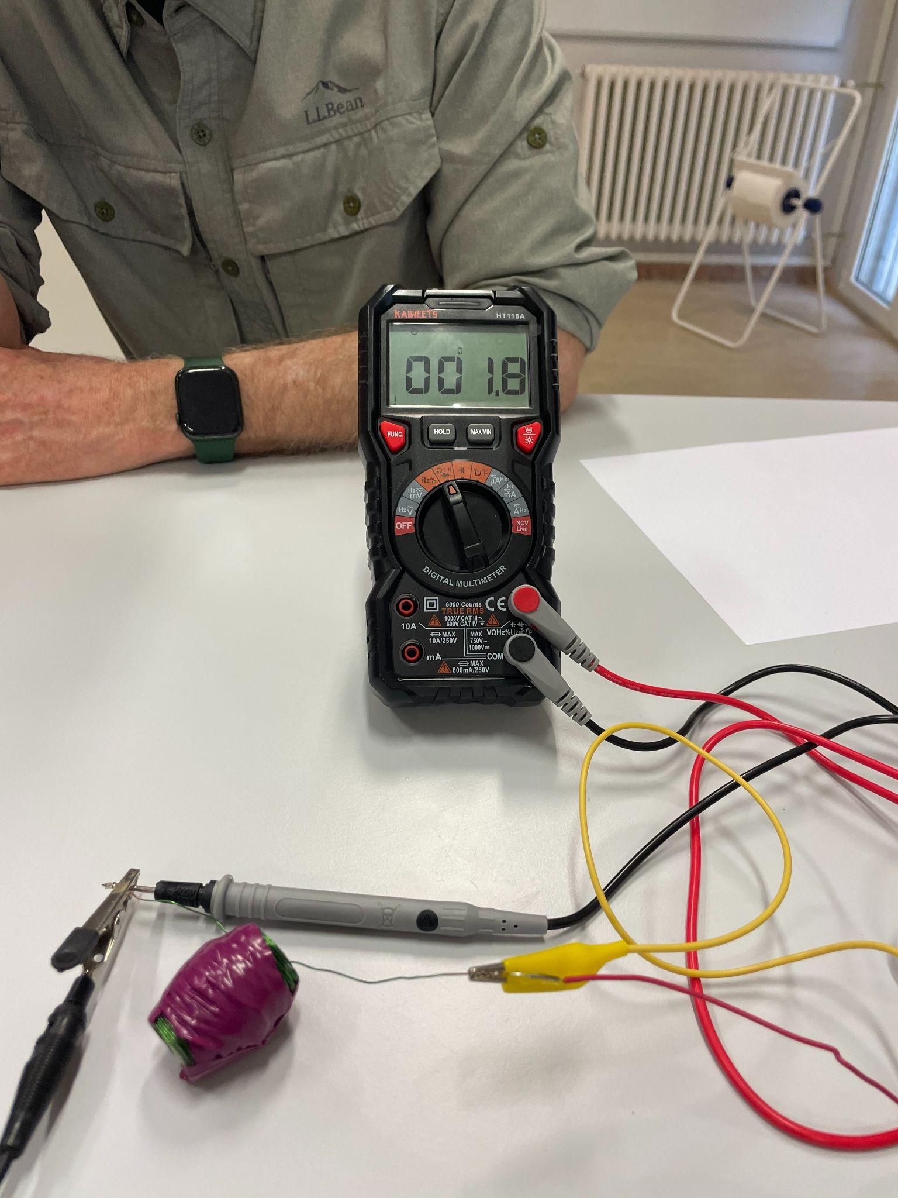
The experimental verification confirmed the theoretical value of the solenoid resistance.
Next we measured the inductance of the solenoid only from a theoretical point of view since we do not have an oscilloscope. Inductance is a physical quantity that measures the ability of a conductor (such as a solenoid) to oppose the variations of electric current that passes through it while electrical resistance measures the opposition of a material to the passage of electric current.
$$L=μ*(N²*A)/l=1,16 mH$$
$L$=inductance, $μ$=electrical permeability of air,$N$=number of turns (in our case 400), $l$=length of the solenoid (in our case 3.5cm).
Both resistance and inductance affect the amount of current and the speed with which it passes through the solenoid, charging and discharging it. In fact, these values ​​determine the speed with which the solenoid's B field is created and dissipated, so it is very important for us to know these values, especially if we do not use capacitors that would make these processes faster. So as a final experimental test, by putting the electrified solenoid and the multimeter in series, we were able to see how quickly the current electrified it entirely and discharged it at the end of the pulse. I attach an image of the experiment below:

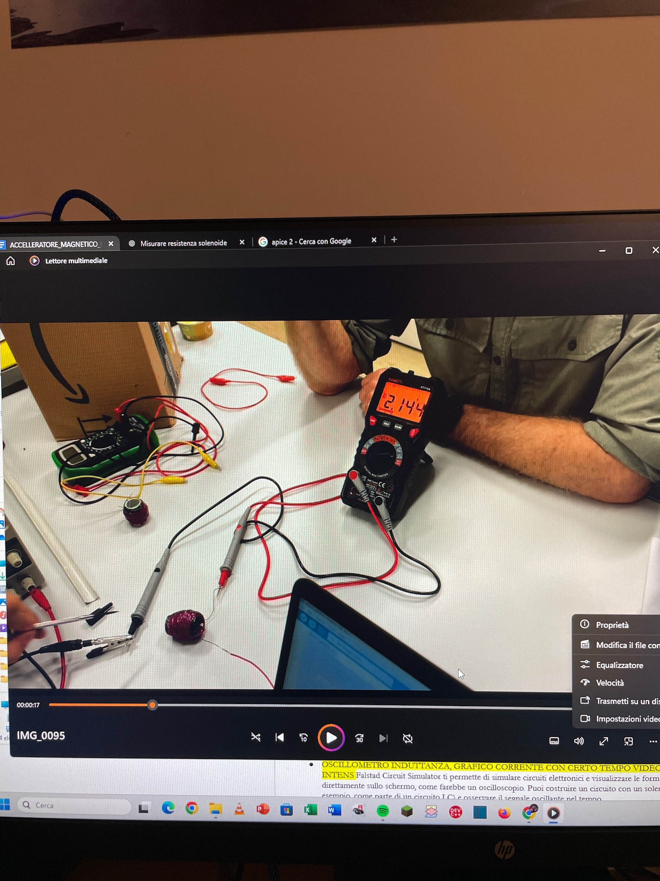

A graph can be constructed that shows the current flow versus time through the solenoid.
Finally, it is useful to calculate the frequency, in Hertz, at which the solenoid oscillates so that the value can be used in virtual simulations. The frequency of a solenoid refers to the rate at which an oscillating alternating current (AC) passes through the solenoid. In an electrical context, frequency is the number of oscillation cycles of the current passing through the solenoid in one second, and is measured in hertz (Hz). In our simulation using the virtual oscilloscope software “Academo,” the time frame was 1 millisecond. When a solenoid is part of an RL (resistive-inductive) circuit, the frequency can be affected by the properties of the solenoid, such as its inductance (L) and resistance (R). A solenoid can also be designed to operate at a specific resonant frequency, which is the frequency at which the RL circuit resonates, maximizing the oscillation of the current. The simulation and frequency formulas would be different if we were in an RLC circuit, which therefore has additional capacitance (capacitors). In any case, the formula for calculating the frequency in an RC circuit is as follows:

$f=R/(2πL)=235.44 Hz$Where $f$=frequency, =resistance and =inductance.$RL$

8. Data Graphs
The graph below expresses the current, expressed in amperes (A), as a function of time (s). It can be noted that the electrification of the solenoid is practically instantaneous, which favors the speed in the interaction ferromagnetic body - field B.

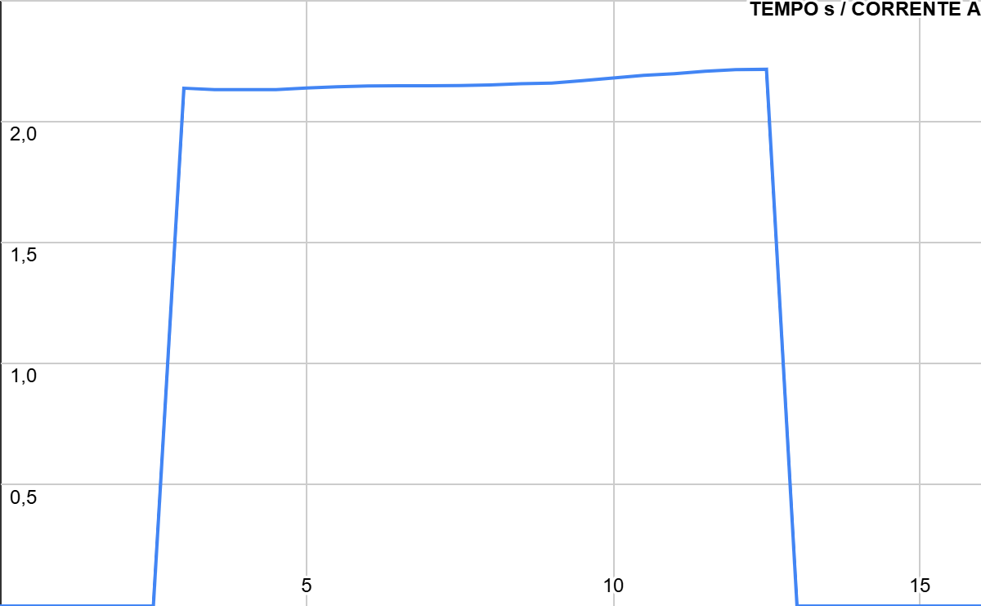
As mentioned above, the following graph is taken from a simulation with a virtual oscilloscope and represents the number of oscillation cycles of the current that passes through the solenoid in a millisecond. The curve is a sinusoid and idealizes the current cycles in the solenoid.
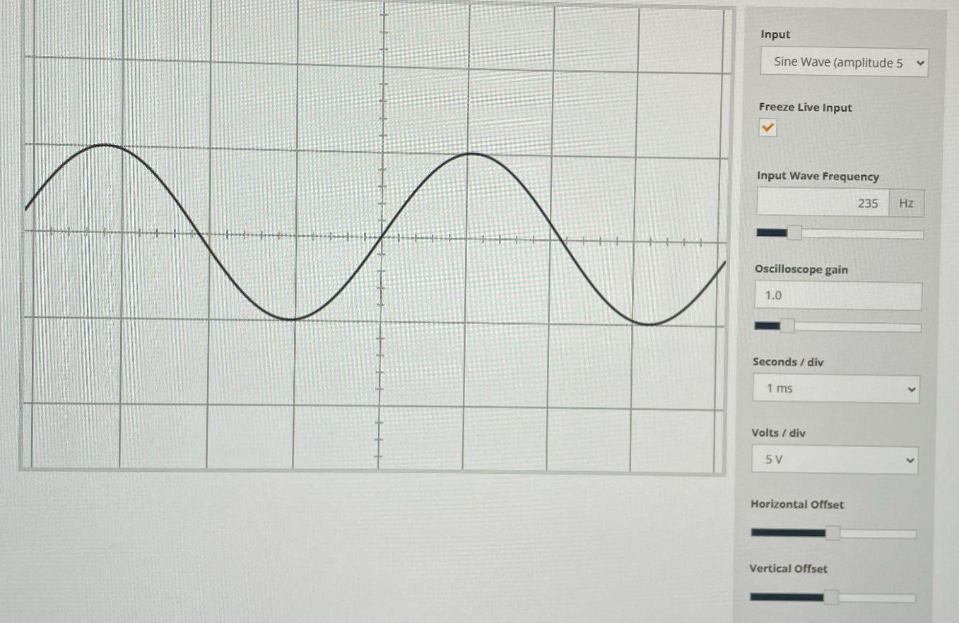

9. Problems Encountered
In the process of achieving any goal you set for yourself in life, you will encounter small or large problems that hinder your path, but personal growth occurs precisely through the resolution of these problems. Like all the other groups participating in HoPE this year, we also had several problems and unexpected events that we were able to address. They allowed us to better understand the functioning of the components or physical processes that we were applying, allowing us to further improve and optimize our final project. Initially, we had difficulty quickly building efficient and ordered solenoids, so under the advice of the teachers, we first created a mechanical and manual tool capable of creating ordered solenoids and then proceeded to automate everything. In fact, initially we used a knob for working fresh pasta to roll the copper wire around the coil support, which helped us become familiar with counting the coil turns and with the manual nature of the process. After that, we decided to speed up the process by replacing the knob with a screwdriver, capable of turning at low speeds. By doing this we were able to make 11 solenoids 3.5 cm long and composed of 400 windings each. We then selected the 5 best performing ones to include in the circuit.
Another difficulty we encountered was to program the switching on and off of the solenoids via Arduino. Christian Cardozo advised us to use relays to do this. Relays are programmable mechanical switches that close one circuit rather than another based on the digital signal coming from the Arduino. Through them we experimentally found the right time during which the first coil would be electrified by the generator to ensure sufficient acceleration to the body.
However, during this process of collecting experimental data, the solenoid remained electrified for too long, which caused the coil to overheat and narrow the main plexiglass tube in which it was inserted. Because of this unforeseen event, we had to use a smaller structure than the initial one, thus resizing the diameter of the solenoids themselves.
Finally, we had trouble choosing an absolute value to attribute to the “not obscuring the sensor” situation, so that the coil would not be activated due to slight changes in ambient light. To overcome this problem, as you can see in the code above, we programmed the sensors to record ambient light values ​​for the first three seconds and then average them. We then defined the “threshold” value, below which to activate the coil, as 90% of the average of the ambient light values ​​recorded by each photoresistor.
In conclusion, our journey has presented us with several challenges that, although they were initial obstacles, have proved to be fundamental for our learning. Each problem we have encountered has given us the opportunity to improve, to better understand how certain components or processes work, and to refine our project. In this context, the spirit of HoPE has manifested itself clearly: learning by making mistakes. Each mistake, each unexpected event, has been a step forward, an opportunity to grow and to strengthen not only our technical skills, but also our team spirit. In the end, thanks to these "mistakes" we have been able to perfect our work, making this experience even more valuable and formative.

10. Performance Analysis
To calculate the speed of the ball as it exits the pipe, we measured the horizontal range and the height of the pipe in order to calculate the other variables.
$$y=\frac{1}{2}at^{2}$$
$$x=vt$$
$$x=5,53 m$$
$$y=1,5 m$$
$$a=9,81 m/s^{2}$$

Sobstituting the known values in the system whe get that $t=0,$553 s and $v=10,0$m/s.
So, the speed of the ball as it exits the pipe is approximately 36 km/h.

11. Optimization
Among the various improvements that can be made to our project are the use of capacitors, mosfets or the use of an advanced circuit in which the coils are managed entirely by photoresistors.
In fact, capacitors would allow us, after being charged to full capacity, to decrease the already minimal electrification time of the solenoid by discharging all the accumulated current onto it. However, in this case we would find ourselves working with a more complicated and dangerous RLC circuit. In fact, we would also have to select the components based on their resistance, capacity and inductance so as to maximize the energy discharges. It would also be good to include recirculation diodes in the system so as not to risk, when the power supply is turned off, reverse voltage peaks that could damage the components. If we wanted to use an alternating current, through capacitors, we would also have to make sure that the frequency of the circuit is equal to the natural frequency of the accumulator. Finally, we could insert them at the moment of discharging the solenoid so as to reuse the voltage resulting from the switching off of the first coil to switch on the following one.
A mosfet would also improve the slower reaction times, instead, in a mechanical switch like the relay. This could be necessary if capacitors are used and consequently electrification times decrease.
Finally, another way, more complex but more elaborate to implement the sequential switching on of the solenoids could use LEDs and photoresistors, managing their resistance. In fact, we have developed a circuit where by switching on LEDs alternately or in different colors, the resistance of a photoresistor could be increased or decreased, so as to channel the current into the photoresistor illuminated by the LED where the voltage is lower. However, the current losses would probably be greater. Below is an electrical diagram of the hypothetical circuit.

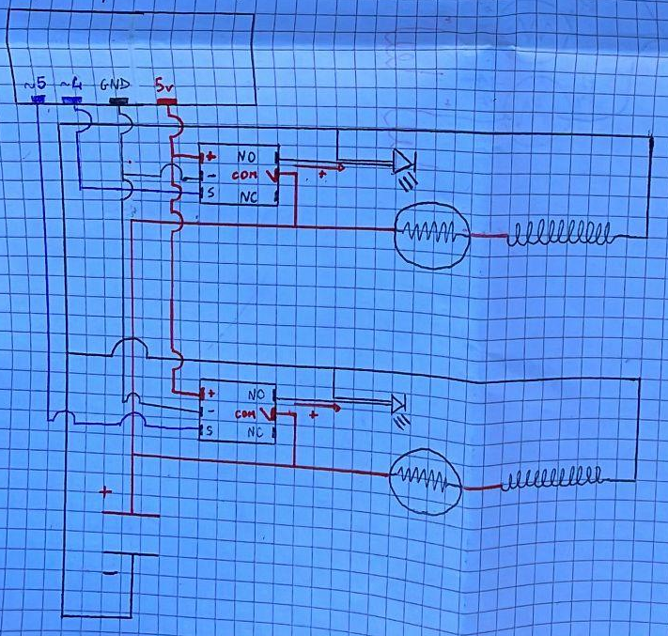

12. Simulation Results
Before soldering the circuit components to the protoboard or even before connecting jumpers and breadboards, it is a good idea to consult electrical circuit simulation software to verify their operation. We did this by checking the correct execution of the relay assignments and the LED-photoresistor system. Below I attach two images taken from the simulation software "Falstad" in which you can see first the open circuit, where the relay is positioned on NC and the solenoid is not electrified, and then an image of the closed circuit, where the relay switch is on NO and current flows in the coil:
Open circuit: Closed circuit:
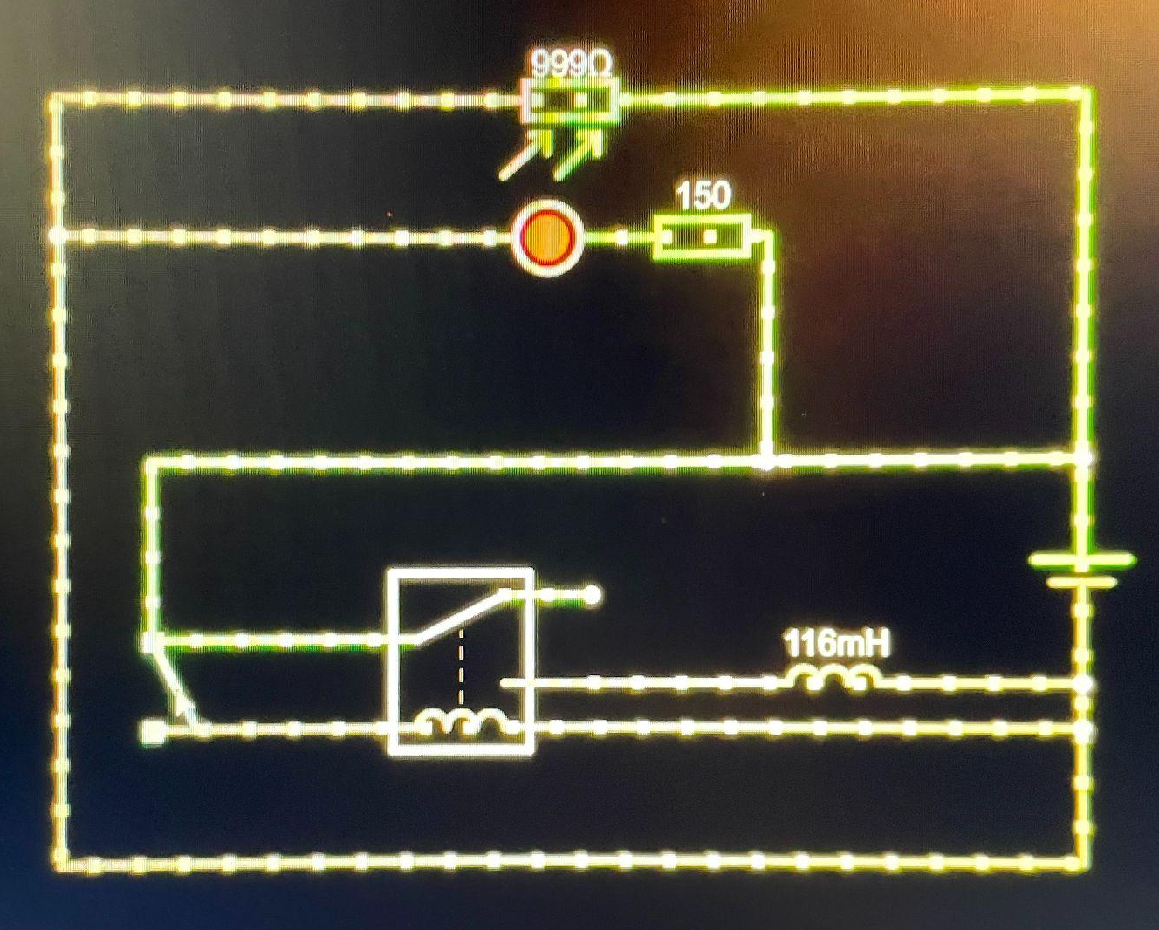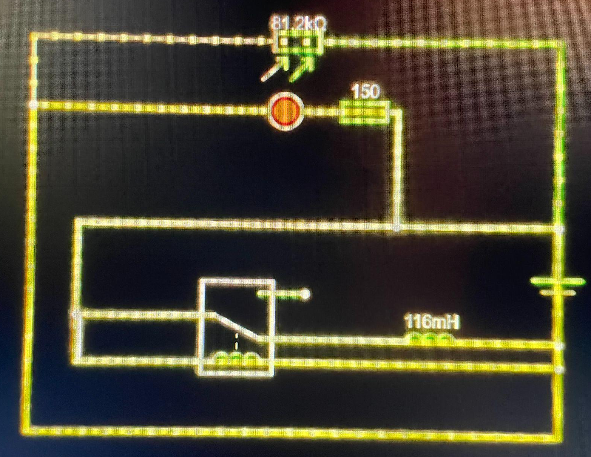

13. Aesthetic Changes
To organize the electrical circuit in an orderly manner and increase its durability over time, a plywood support surface is usually attached to the main structure, previously described. This allows for easy organization and distribution of the electrical components, facilitates transportation and facilitates connection to a voltage generator. To create the described structure, the square supports of the plexiglass tube are fixed to the surface, the supports must in fact be placed perpendicular to the support surface. After that, the protoboards or breadboards, and the resulting wiring, are fixed to the base. Eventually, to facilitate connections or extend the cables through the plywood sheet, sections of copper sheets, not insulated and adhesive, can be used to extend the circuits along the surface itself. This would facilitate connections to a voltage generator. Furthermore, to enrich the project itself, displays can be implemented in the structure that show the current passing through the circuit, the voltage, the speed of the body or even the percentage of filling of capacitors if used. Finally, it would be interesting to also add mechanical components capable of modifying the angle of the barrel, but in this case if you use experimental timings in your code they would prove ineffective.

14. Future Projects
In the near future I hope to have the opportunity to develop other projects, similar to this accelerator, which include the motion of bodies, induced by "invisible" forces. In fact, during the brainstorming phase, interesting ideas were presented that, although very intriguing, were not realized. Some of these are elaborations of our project, with different objectives, while others exploit completely different physical principles but obtain a similar result. Among these, the most stimulating, in my opinion, is an electrostatic "salad bowl" accelerator (Salad Bowl Accelerator). This project, exploiting the phenomena of attraction and repulsion of charges of equal or opposite signs, accelerates electrically conductive bodies. In fact, its structure consists of a bowl of insulating material crossed by strips of conductive material electrified in an alternating manner with positive or negative charge. In fact, after having given the body an initial acceleration, it will proceed along the edge of the bowl assuming a positive charge when passing over a positive lattice, from which it will then be repelled, until it heads towards the next, negative one, which attracts it, continuing its motion. In this case, the physical principle of the Coulomb force is exploited in a non-uniform electric field, generated by alternating strips of positive and negative charge on the surface of the bowl. When a conductive sphere moves along the surface, it is attracted and repelled by the charged regions, acquiring charge by contact or induction. The resulting electric field accelerates the sphere towards the areas of opposite potential, repeatedly converting electrical energy into kinetic energy. The sphere, despite being made of insulating material, is painted with graphite paint, electrically conductive. Interested in this project, I tried to make it in my home garage, powering the circuit with 30V, however the effect turned out to be almost imperceptible since a Van Der Graaf generator must be used. Therefore, I hope to be able to use this tool in the future to complete my work. Below I attach photographs of the work I have done so far.
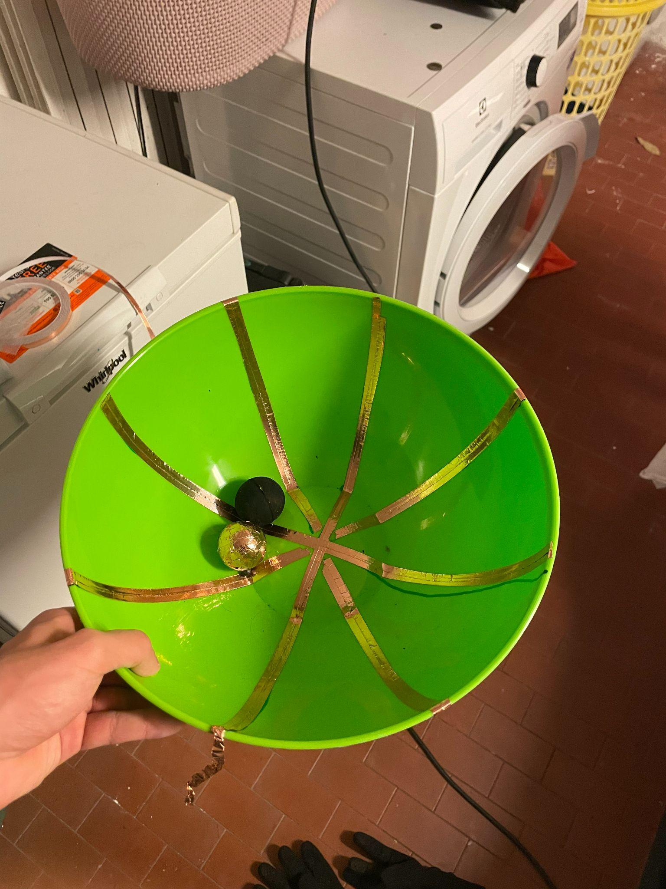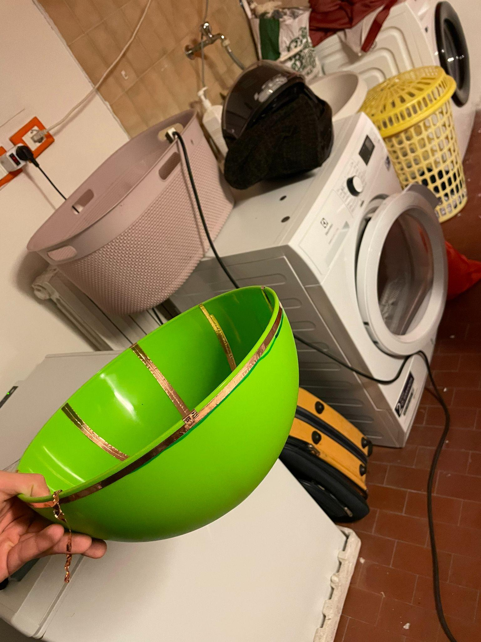
We have also been offered several variants of our final design, such as a circular electromagnetic accelerator or an interactive version. The first would allow for greater speed, but would require more precise and sensitive sensors than photoresistors, such as photoelectric or infrared sensors. This version could simulate the operation of the CERN particle accelerator in Geneva, but would work differently.
Finally, it would be easy to make an interactive version of the same circular accelerator, eliminating complex parts of the circuit, that is, making the sequential switching on of the solenoids manual. This could be done using push buttons and would constitute a challenging coordination game for the participants, especially if the structure were placed vertically. Doing so would add the effect of the weight force of the body and the goal would become the completion of a full turn of the circular tube.
My goal is to implement all these ideas, if possible, during the next year of HoPE or external programs.

15. Conclusions
With respect to what was said above, I believe that our project has met our expectations, but that it could certainly, as I hope, be improved by other students.
Finally, to conclude the description of the project I took part in this year, I want to focus on what makes HoPE truly special. During this journey, I grew both as a student and as a person, finding myself in a free, meritocratic environment free from superficial judgments. The aspect that I appreciated the most is the cosmopolitan and open environment in which we work, where knowledge is a goal that unites professors, experts and students. HoPE is the right place for those who want to experiment, discuss and collaborate without fear of making mistakes, because here there are no "stupid" questions, in fact every doubt is an opportunity to grow. In this project, there is no rigid hierarchy between students and professors, but a continuous and constructive dialogue, everyone is always willing to listen to you, help you and even be inspired by your ideas.
At the end of this journey, I realize how much HoPE has enriched my way of thinking and working, strengthening my desire to explore, innovate and share. More than just a project, it was an experience that I will always carry with me.

16. Final notes
We also built an interactive demonstration to show how an induced magnetic field works, and how challenging it is to time the correct moment to turn it off.
We 3D printed a circular rail with four solenoids placed around it. Each solenoid could be activated using a push button, so users had to press the buttons at exactly the right time to keep the ball moving around the track without it stopping.
Video of the circular accelerator working: https://youtube.com/shorts/YEwtCUZ5q4Q

16. References
Below I attach, organized by topic, all the sources we relied on for the creation and description of the project.
 | SIMULATIONS | NOTES | TRANSLATION | SCHEMATICS | CAD
SOURCE | VIRTUAL OSCILLOSCOPE | MY NOTEBOOK | DOCUMENT TRANSLATION TO ENGLISH | CIRCUIT SCHEMATICS | CAD
SOURCE | CIRCUIT-SIMULATION | YT VIDEOS | WORDS TRANSLATION | ARDUINO CODE | -
SOURCE | - | EXTRA-CURRENT CLASSES | MALACHI MACON | CHRISTIAN CARDOZO | -
SOURCE | - | TEACHERS | - | - | -
SOURCE | - | - | - | - | -

