Heartz - an Anatomycal Heart Model
Heartz is an anatomical, realistic, and educational model that represents the heart in a
concrete and accurate way. Built in 3D, it allows you to learn and observe the functioning
of the chambers and the cardiac circuit.
To create the Heartz model, we divided ourselves into three groups with three different
areas of work, in order to focus more specifically on each part and make the model as
lifelike as possible. We believe that accuracy is essential for a project with this purpose.
We also dedicated ourselves to the exterior details, because in addition to the functionality, we believe that the actual resemblance to a real heart is important. We also
took care of the box and related objects to make the project presentation more effective
and engaging.
Supplies
To create the project, we used the following materials:
1. colored water with red artificial dye;
2. tubes of different sizes;
3. pumps and valves;
4. arduino board and wires;
5. servos;
6. wood and paint;
7. 3d printer;
8. silicone and molds;
Step 1: Structure
We prepared a 3D model of the heart on Onshape, splitting it lengthwise, and printed it
in four parts to optimize the printing time. After printing, we then glued the parts together
with hot glue to create the complete structure.
We also created a model of the lungs to give a better idea of how the cardiac cycle
works and how it passes through the lungs and then created a 3D model for the atrium
and ventricles, and once printed, we poured Ecoflex silicone into it using the vacuum
casting technique.
For realizing the silicone models of the atrium and ventricles we used the following
materials:
*a glass to prepare the silicon mixture;
*a scale to weight properly the silicone needed;
*air pump and bell (with pedestal) to reduce the air bubbles.
and we followed the following steps: (Caution! Before starting the entire process,
lubricate the mold to facilitate the removal of the silicone once it's dry!)
1) Pour the Ecoflex into a small bottle inside a bag, filling it about halfway (about 15.4g);
(The two Ecoflex components form the glue we need).
2) Mix the contents of the bag for about a minute;
3) Close the bag, and after flipping it over, make a small cut in one corner;
4) Pour the mixture into the designated mold;
5) Place the mold inside the bell and activate the air pump;
6) Wait until the pressure reaches almost maximum, then let it release until the pressure
is at 10;
7) Repeat the procedure for about 5 minutes;
8) Remove from the bell and wait for 4 to 8 hours.
Step 2: Circuits
To create the pump part, we first colored the water red (we chose water to allow it to flow
easily through the tube circuit). We then cut the tube as needed and connected the
valves and the manual pump to create a closed circuit.
We then assembled the circuit by opening and closing it inside the model, drilling the
previously made 3D model at the points where the blood flows between the atrium and
ventricle, and towards the outside, to allow the tube to pass through, but first of all we
made sure to pass the tube, before sealing it, through a 3D model of the lungs, also
created by us, in order to demonstrate the pulmonary circulation (from the right atrium to
the ventricle).
Step 3: LEDs
We have created a program that, once the LEDs are connected to the board, allows us
to have two modes by clicking one button:
*Manual: where we have a button that allows us to activate the LEDs in a cycle (red to
indicate systemic circulation, blue for pulmonary circulation) with the real-time timing of
the cardiac cycle;
*Automatic: where at the end of each cycle, the LEDs are reactivated without the need
for manual intervention;
We then connected the servos to the board, and we have a program that allows them to
activate along with the LEDs. In manual mode, they activate when pressing the button,
and in automatic mode, they activate automatically.
(all according to the model below)
Step 4: Addictional Details
We created a wooden structure with a small door at the back to contain and hide the
wires, and with small openings on the sides to allow the buttons to pass through (to
change the mode and, if needed, to activate the LEDs). On top, we placed a pedestal
that holds the heart model in place and prepares it for display. We then painted the box
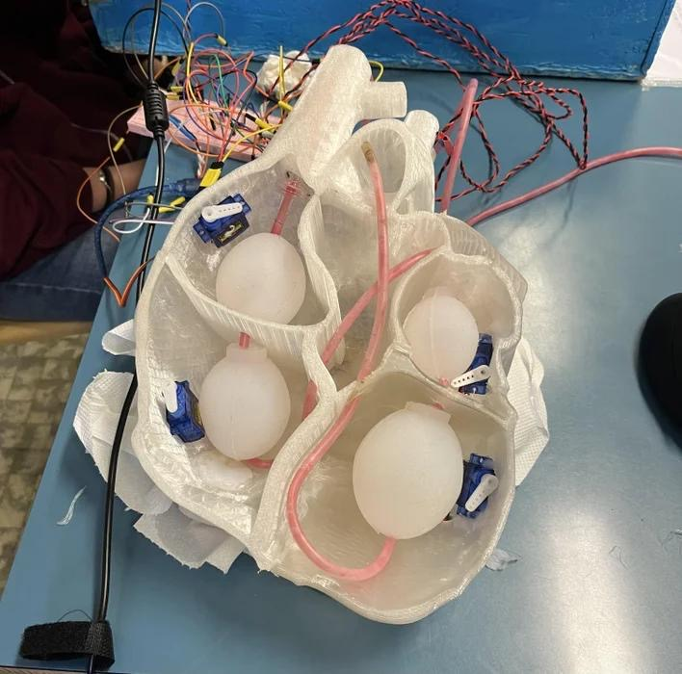
light blue and the pedestal white.
