Sonorix, laser guitar
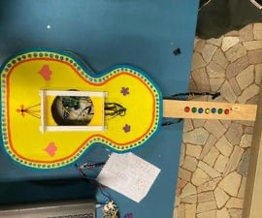
With our project we wanted to create a musical instrument that was fun to use and accessible to everyone. This project helped us to
deepen our computer knowledge and practical skills applicable to this field, such as the use of an mp3 and arduino.
We decided to create this guitar because we were all accumuned by the passion for music and the desire to create a project that
merged technology and music.
This guitar is composed of 3 lasers and 7 keys. The 3 lasers are used to choose the octave to be played (low, medium, high), while
the 7 keys are used to decide which of the 7 notes of a scale to play. The sound will be produced by interrupting a laser and pressing
a button simultaneously.

Supplies
STRUCTURE
plywood
foam
velcro
paint
LASER CIRCUIT
3 laser
3 photoresistors
3 resistors of 100kΩ
many threads
KEY CIRCUIT
7 keys
7 resistors from 20kΩ
Ribbon cable
Arduino
breadboard
speaker
micro sd

Step 1: Planning
We started by making a cardboard model to see which measurements would be fine to make the guitar quite realistic.

Step 2: Start Programming
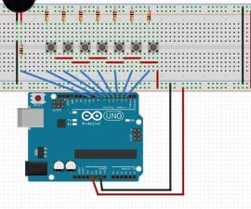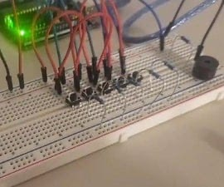
We started to build a primitive version of the arduino, with only one laser connected to 7 keys and a buzzer.
We connected the 7 keys with jumpers and put 7 resistors from 20k.

Step 3: 3 Lasers
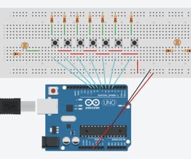
We implemented the code by adding 2 more lasers to change the octave.

Step 4: Combine the 2 Programs
Instead of using a music shield, as is usually done, we have downloaded the mp3 files with all 21 possible sounds that can be
produced on an SD card. The sounds were recorded by us using a real guitar. We combined the SD card with the arduino program that
we had already written.

Step 5: Connect Lasers and Photoresistors
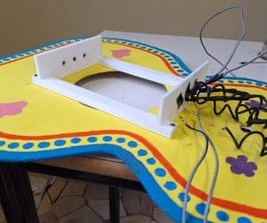
Finally, we calibrated the lasers and photo resistors and mounted them on a structure created with a 3D printer suitable to hold both
lasers and sensors still.
onShape model URL code:
https://cad.onshape.com/documents/3cdb2f8f322db6cc52d9e11c/w/9b5f508162f401a943cb2697/e/8dd96ef8dd2b17cddc10a399?
renderMode=0&uiState=67fd272f8541cb14f640030d

Step 6: Create the Two Wooden Templates
We created the two silhouettes using plywood and cutting with an electric saw.

Step 7: Making the Guitar Body With Foam
We carved a block of foam with a tool called hot-wire

Step 8: Make the Handle
we took a piece of wood with which to take the correct measurements for the handle, then, once we found the right size we cut a
piece of plywood. To make the foam part of the handle we always took a block of foam and cut it with a hot-wire and finished with a
file.

Step 9: Make the Holes
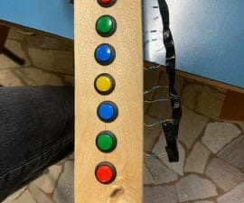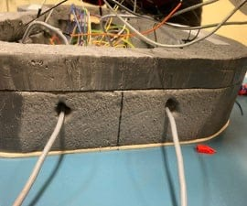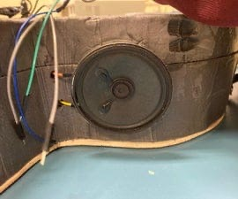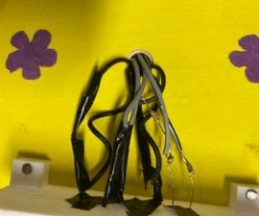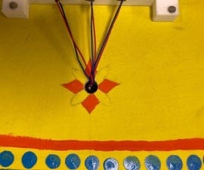
we made 7 holes on the handle to be able to insert the buttons, two holes on the case to connect the power cables, A hole on the wall
of the foam case to insert the case and two holes on the upper silhouette of the wood to insert the laser cables and sensors inside
the case.

Step 10: Put on the Velcro
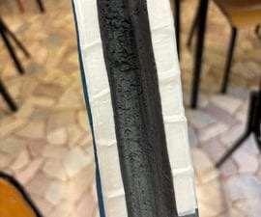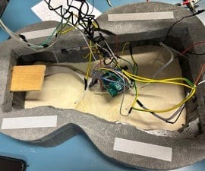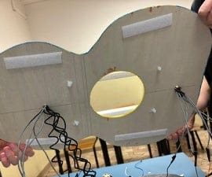
We cut pieces of velcro and attached them to the shape of foam and wood and the same thing for the handle.

Step 11: Combine the Whole
We assembled the structure with the computer part.

Step 12: Color Everything
Finally we colored everything.

